FOR IMMEDIATE RELEASE

KLAUS Multiparking America Inc. Launches the Revolutionary kVario 8000 Series Semi-Automatic Puzzle Parking System
New Jersey, USA – January 7, 2025 – KLAUS Multiparking America Inc., a leader in cutting-edge parking solutions, is thrilled to announce the launch of its latest innovation, the kVario 8000 Series Semi-Automatic Puzzle Parking System. Designed to redefine parking efficiency and versatility, the kVario 8000 Series is the ultimate solution for modern urban and suburban developments.

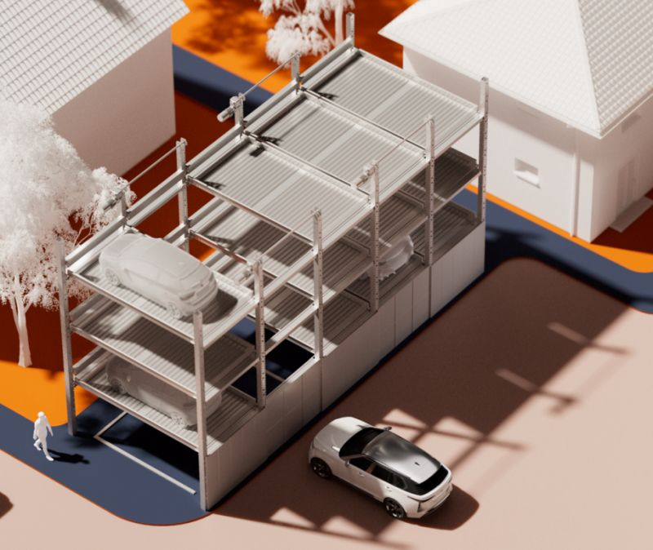
Redefining Parking Design for the New Year:
As cities grow and space becomes increasingly scarce, the need for innovative parking solutions has never been greater. The kVario 8000 Series offers unparalleled flexibility, making it ideal for a wide range of projects, including:
- Mixed-Use Developments
- Multifamily Housing
- Student Housing
- Hotels & Resort-Style Communities
- Commercial Garages
Key Features and Benefits of the kVario 8000 Series:
- Scalable Design: Accommodates up to 5 parking levels, both above and below ground.
- Space Optimization: Maximizes parking capacity for residential, commercial, and mixed-use projects.
- Eco-Friendly Technology: Reduces emissions and traffic congestion by streamlining parking operations.
- Flexible and Modular: Tailored to meet the unique demands of urban and suburban developments.
- Seamless Integration: Easily incorporated into existing or new project infrastructure.
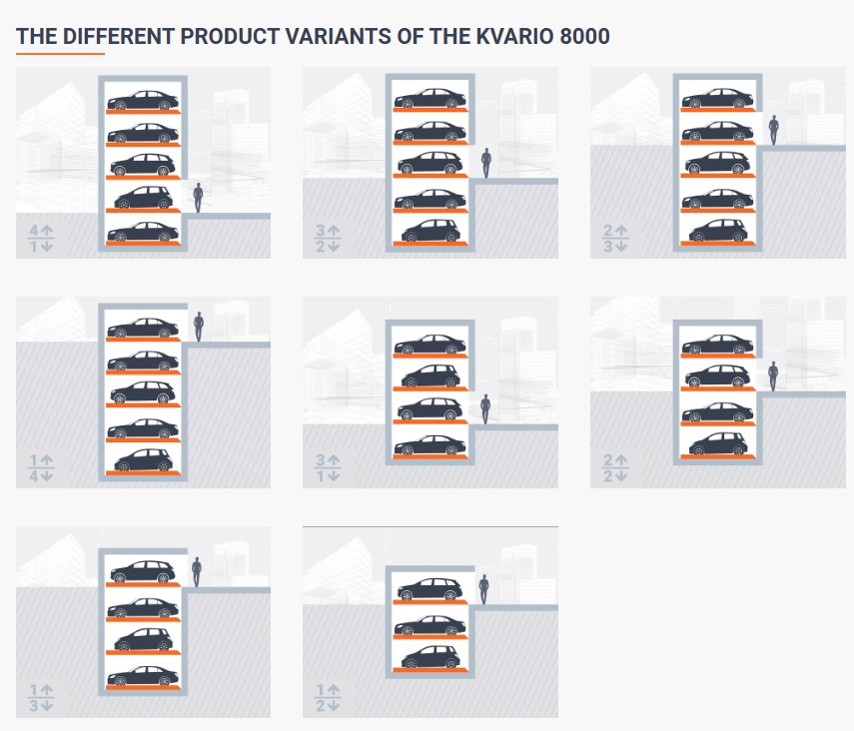

Turnkey Solutions for Architects, Engineers, and Developers:
KLAUS Multiparking America Inc. provides end-to-end support, from complimentary consulting to installation, maintenance, and service. Our team is dedicated to ensuring every project achieves maximum efficiency and sustainability.
Experience the Future of Parking:
“The kVario 8000 Series embodies our commitment to innovation and excellence in parking solutions,” said Christopher Tiessen, President/CEO, KLAUS Multiparking America Inc. “With German engineering and a focus on modern design, we’re empowering architects, engineers, planners, and developers to rethink parking for the 21st century.”
Learn More and Get Started:
To explore how the kVario 8000 Series can transform your next project, visit our website at https://us.multiparking.com/products/225/kvario-8000/ or contact us at: america@multiparking.com
About KLAUS Multiparking America Inc.
KLAUS Multiparking America Inc. is a subsidiary of KLAUS Multiparking GmbH, a global leader in automated and mechanical parking solutions with over 60 years of experience. Headquartered in New Jersey, we provide innovative, turnkey parking solutions tailored to meet the needs of clients across the United States. To see our complete product line visit:
https://us.multiparking.com/products/

Cutting-Edge Innovation. German Engineering. It Must Be KLAUS!

Media Contact:
Donna Wagener
Director Business Development
KLAUS Multiparking America Inc.
Email: donna@multiparking.com
Phone: +1 646-244-4491

